

**PROVINCIAL PUBLIC HEALTH LABORATORY NETWORK**

Dr. LA Miller Centre, 100 Forest Road, St. John’s, NL A1A 3Z9 (709) 777-6583 www.publichealthlab.ca

**Important Information on collecting and shipping specimens for monkeypox virus testing.**

*The Department of Health and Community Services distributed memo to Health Care Providers May 26.*

**Collection of Monkeypox Virus Specimens**

1. Don appropriate personal protective equipment (PPE). Refer to instructions for PPE as provided by Infection Prevention and Control Department.
2. Collect TWO samples from the lesion(s):
   1. One using the individually packed swab and put in the 2ml sterile tube (Dry Swab).
   2. One using any of the listed swab/ transport media sets (UTM or VTM or YOCON or ALLTM).

Ensure the swab is placed back into the correct tube for accurate results.

Swabs must be maintained and shipped in refrigerated temperature conditions.

1. Tissue if collected is to be put in sterile tube/container (no fluid) and maintained/shipped frozen.
2. Clearly label at the point of collection using name, health care number, date, time of collection, and source of specimen.

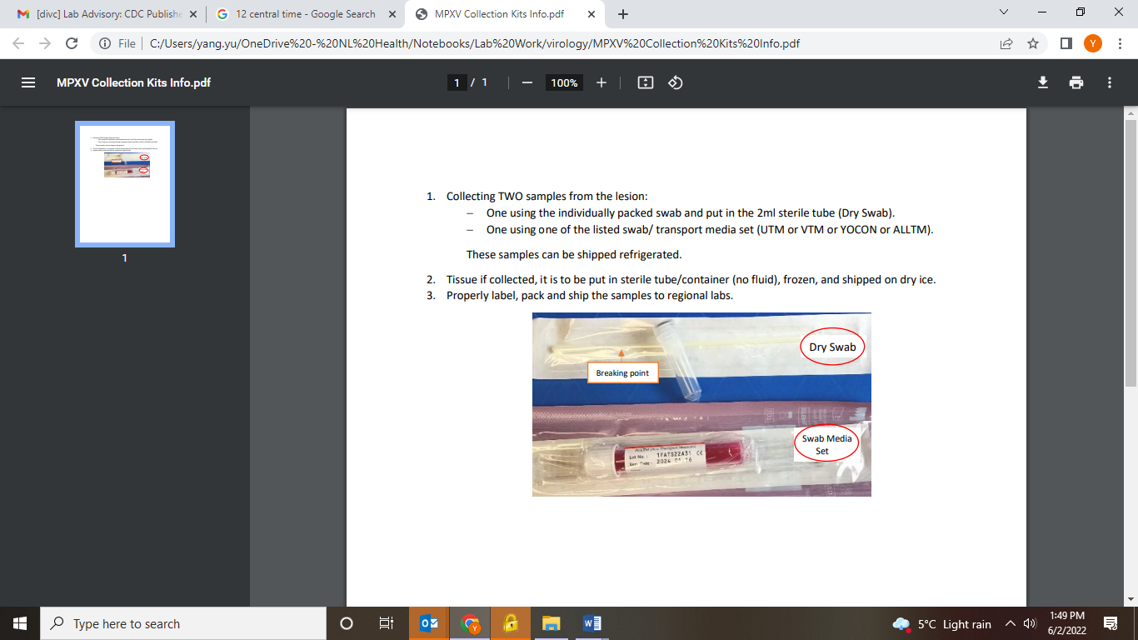

**Packaging and Shipping of Monkeypox Virus Specimens**

Swab samples are shipped refrigerated and tissue shipped in frozen conditions.

**Packaging of Specimens:** Individuals packaging specimens must hold certification in transportation of dangerous goods (TDG) road or air as appropriate or directly supervised by a person certified in TDG.

TDG training vendor recommendation (BIO101 for road + BIO105 for air): <https://complianceacademii.com/dangerous-goods-compliance-courses/>

**Shipping by Road:** Package specimens using UN3373 Category B (P650 packaging) with an additional label stating “Temporary Certificate -TU 0886” in clear print on contrasting background. PHML can supply a template for these labels.

**Shipping by Air and shipping of Contaminated Waste Materials:** Specimens must be packaged according to requirements for UN2814 Category A (P620 packaging).

Reach out to the microbiologist on-call (MOC) if further guidance is required.

